ASSIGNMENT 1

Basically, there are two main categories of computer languages, namely Low Level Language and High Level Language. 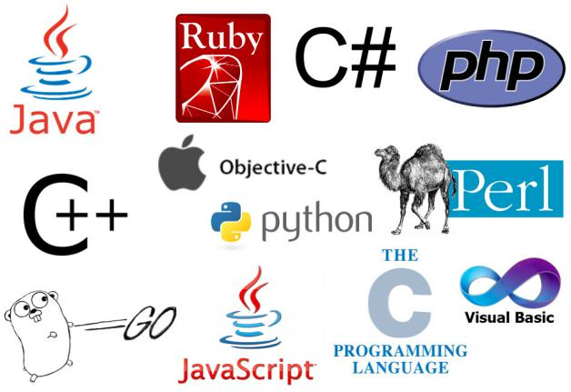

## **1] Low Level Languages**

Low level languages are the basic computer instructions or better known as machine codes. A computer cannot understand any instruction given to it by the user in English or any other high level language. These low level languages are very easily understandable by the machine.

The main function of low level languages is to interact with the hardware of the computer. They help in operating, syncing and managing all the hardware and system components of the computer. They handle all the instructions which form the architecture of the hardware systems.

1. **Machine Language :**

This is one of the most basic low level languages. The language was first developed to interact with the first generation computers. It is written in binary code or machine code, which means it basically comprises of only two digits – 1 and 0.

### Assembly Language :

This is the second generation programming language. It is a development on the machine language, where instead of using only numbers, we use English words, names, and symbols. It is the most basic computer language necessary for any processor.

EG : Assemblers

1. **Middle level language :**

C is called middle-level language because it actually binds the gap between a machine level language and high-level languages. A user can use c language to do System Programming (for writing operating system) as well as Application Programming (for generating menu driven customer billing system ). That's why it is called the middle-level language.

EG : Middle level - [C++](https://www.dotnettricks.com/learn/cpp" \t "https://www.dotnettricks.com/learn/c/_blank), [C](https://www.dotnettricks.com/learn/c/introduction-to-c-language" \t "https://www.dotnettricks.com/learn/c/_blank), FORTH, Macro-assemble

**3] High Level Language :**

When we talk about high level languages, these are programming languages. The important feature about such high level languages is that they allow the programmer to write programs for all types of computers and systems. Every instruction in high level language is converted to machine language for the computer to comprehend.

Some prominent examples are : Ada, Modula-2, Pascal, COBOL, FORTRAN, BASIC.

### Scripting Languages :

Scripting languages or scripts are essentially programming languages. These languages employ a high level construct which allows it to interpret and execute one command at a time.

Scripting languages are easier to learn and execute than compiled languages. Some examples are AppleScript, JavaScript, Pearl etc.

### Object-Oriented Languages :

These are high level languages that focus on the ‘objects’ rather than the ‘actions’. To accomplish this, the focus will be on data than logic.

The reasoning behind is that the programmers really cares about the object they wish to manipulate rather than the logic needed to manipulate them.

Some examples include Java, C+, C++, Python, Swift etc.

### C) Procedural Programming Language :

This is a type of programming language that has well structured steps and complex procedures within its programming to compose a complete program.

It has a systematic order functions and commands to complete a task or a program.

EG : FORTRAN, ALGOL, BASIC, COBOL are some examples.

# ASSIGNMENT 2

# What Is Cloud Networking or Cloud-Based Networking?

[Cloud networking](https://www.sdxcentral.com/cloud/" \o "Cloud Infrastructure), or cloud-based networking, is when some or all of an organization’s networking resources are hosted in [the cloud](https://www.sdxcentral.com/cloud/definitions/what-is-cloud/" \o "What is the Cloud? &#8211; Definition).



The network resources are hosted on a public, private or hybrid cloud platform. Network resources can be virtual routers, bandwidth, virtual firewall, any network management software and more.

It is based on cloud computing, which is the centralization of computing resources that are shared between users. It shares the network in the same way and has spurred a trend in pushing more network functions into the cloud.

**TYPES :**

1. Cloud-enabled networking : Using the cloud resources, the management of local network/connection like SAAS network management as well as anti-virus solution.
2. Cloud-based networking : Using the network resources completely from the cloud. The equiments needed for the utilization should be cloud based.